Azure Machine Learning Assessment

Creation of machine learning resource group -:

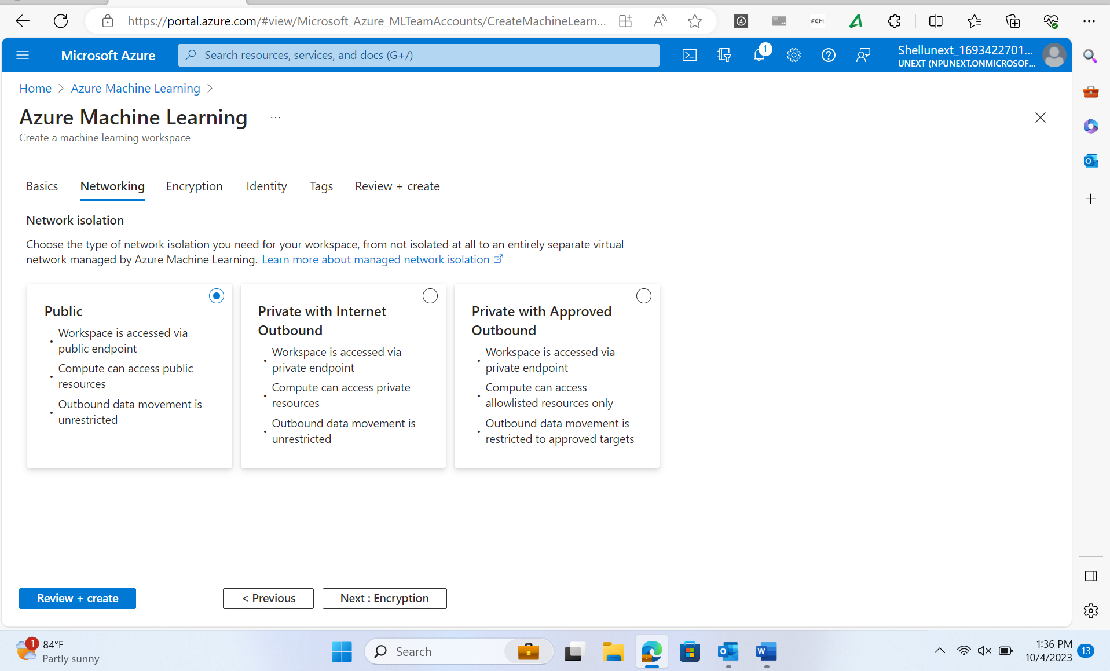

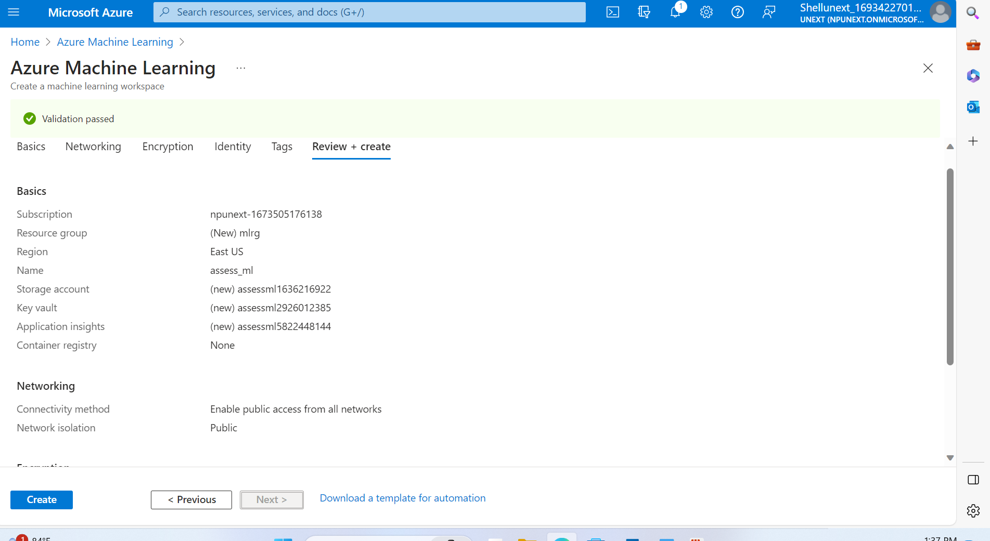

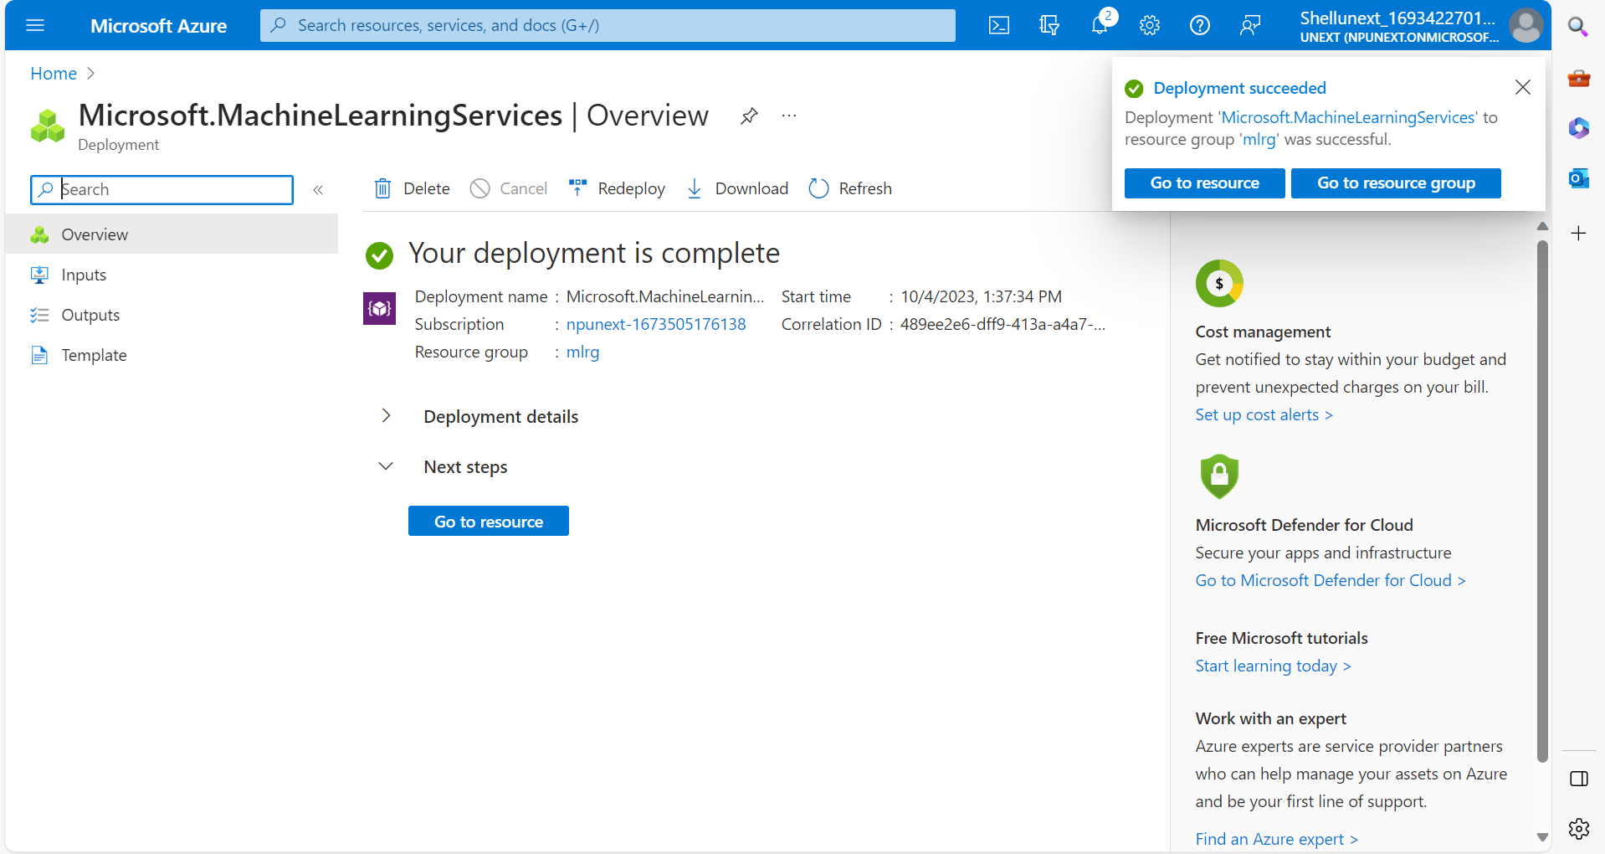

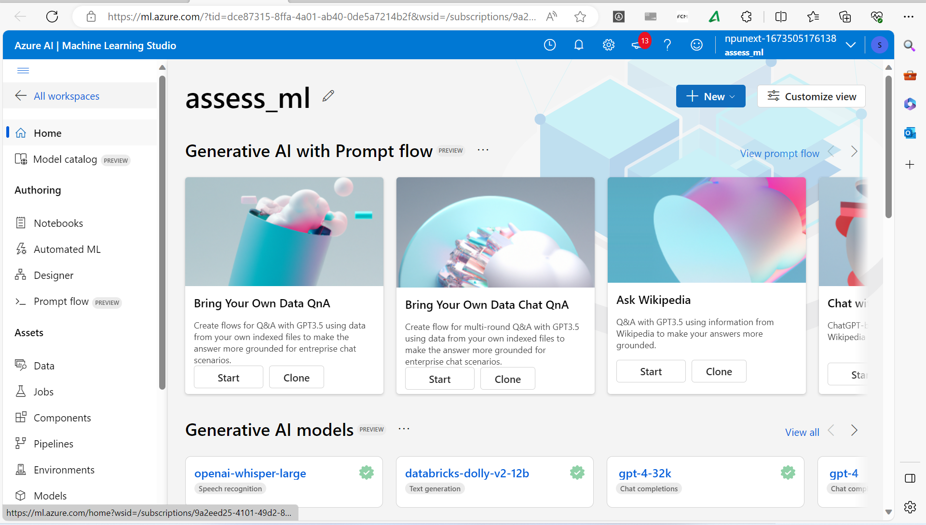

Uploading data in blob storage:

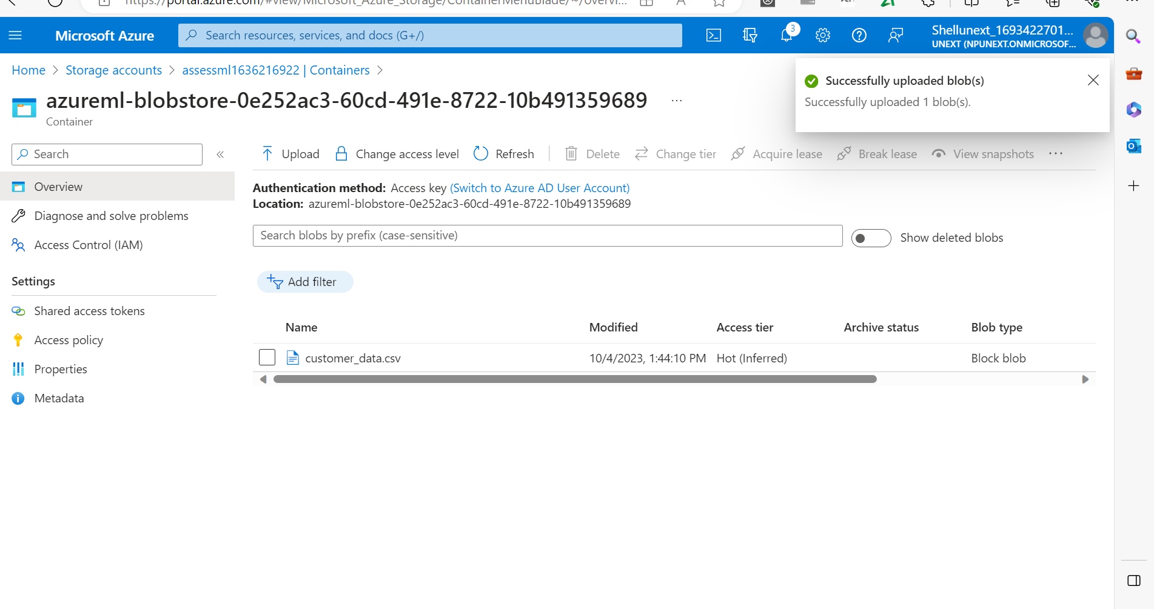

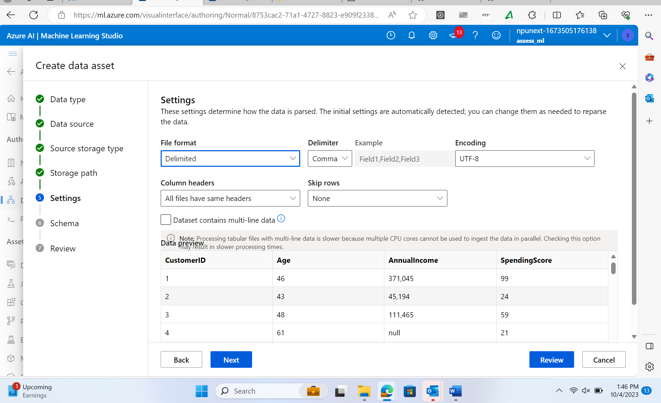

Dataset loaded

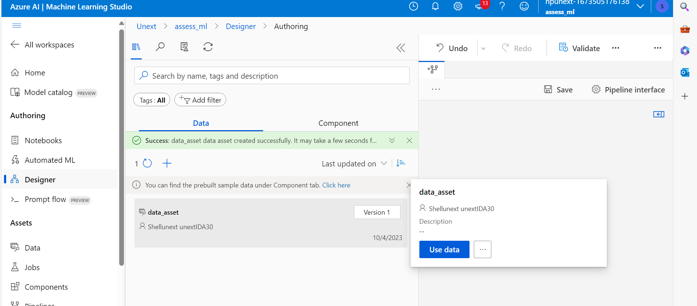

Cleaning of missing data: On columns age, income and spending score

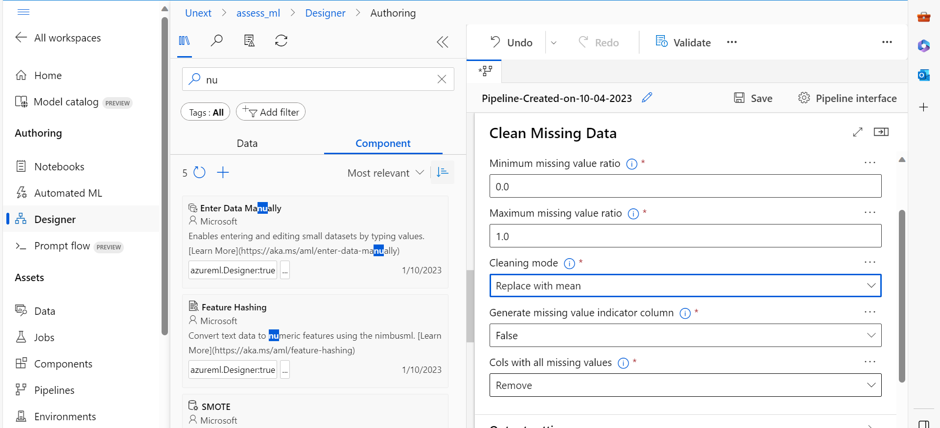

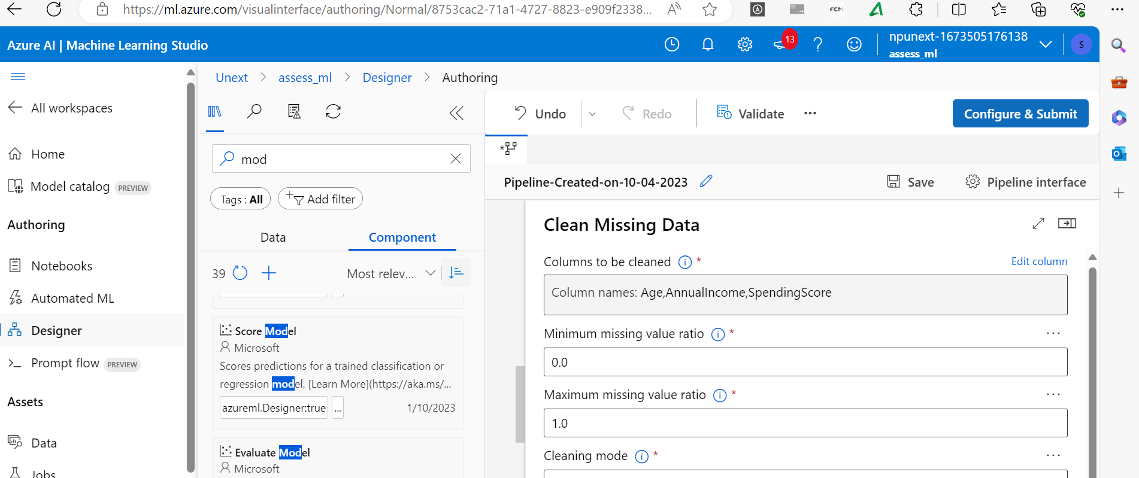

Model development :

Choosing linear regression model for the predicting the customer purchasing behavior.

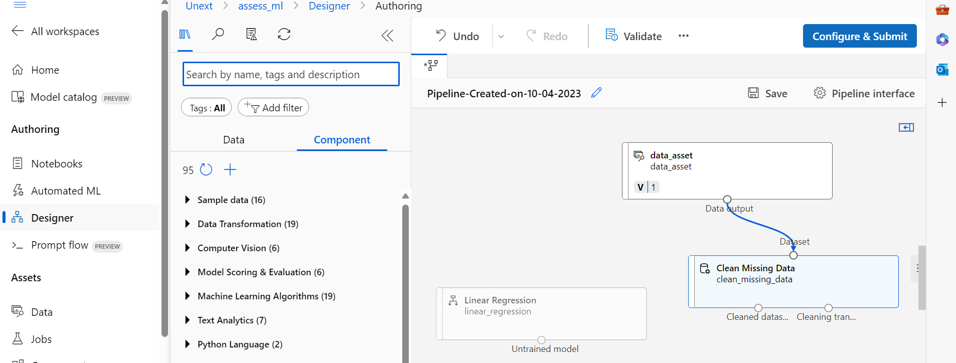

Splitting dataset into training and testing :

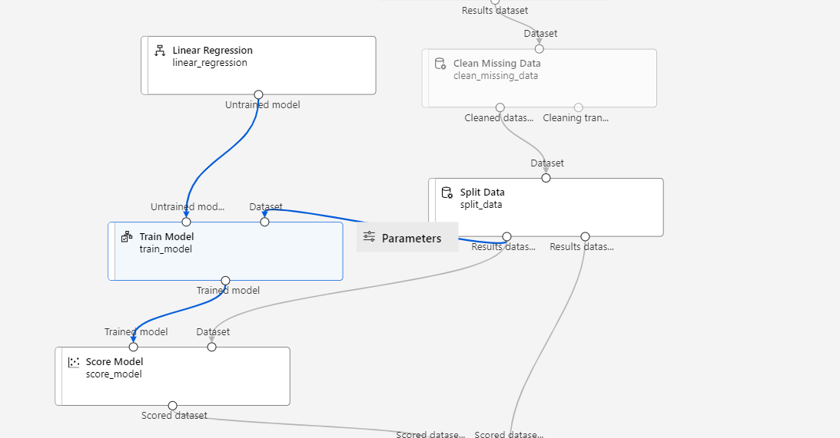

Training the model on 75% of the training data

After the model is trained the score model is used.



Evaluation model is used to check the accuracy of the model trained by comparing it with the testing data.

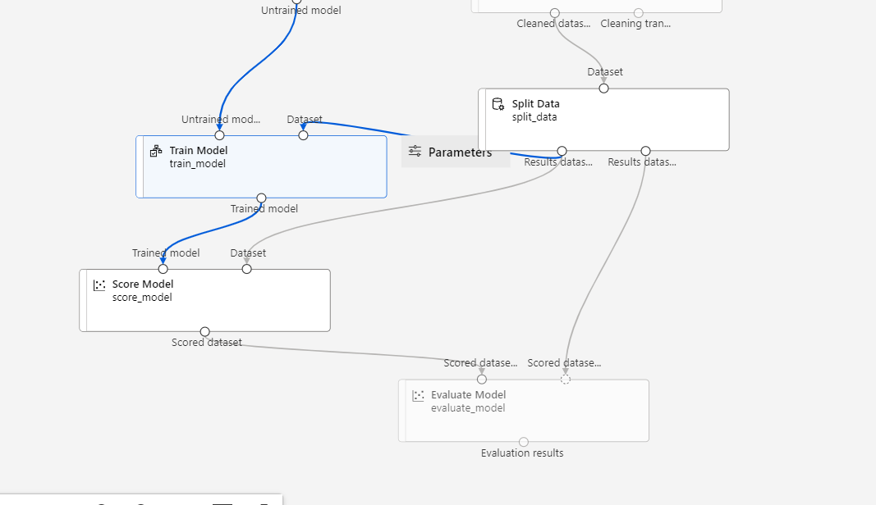

Hyperparameter tuning:

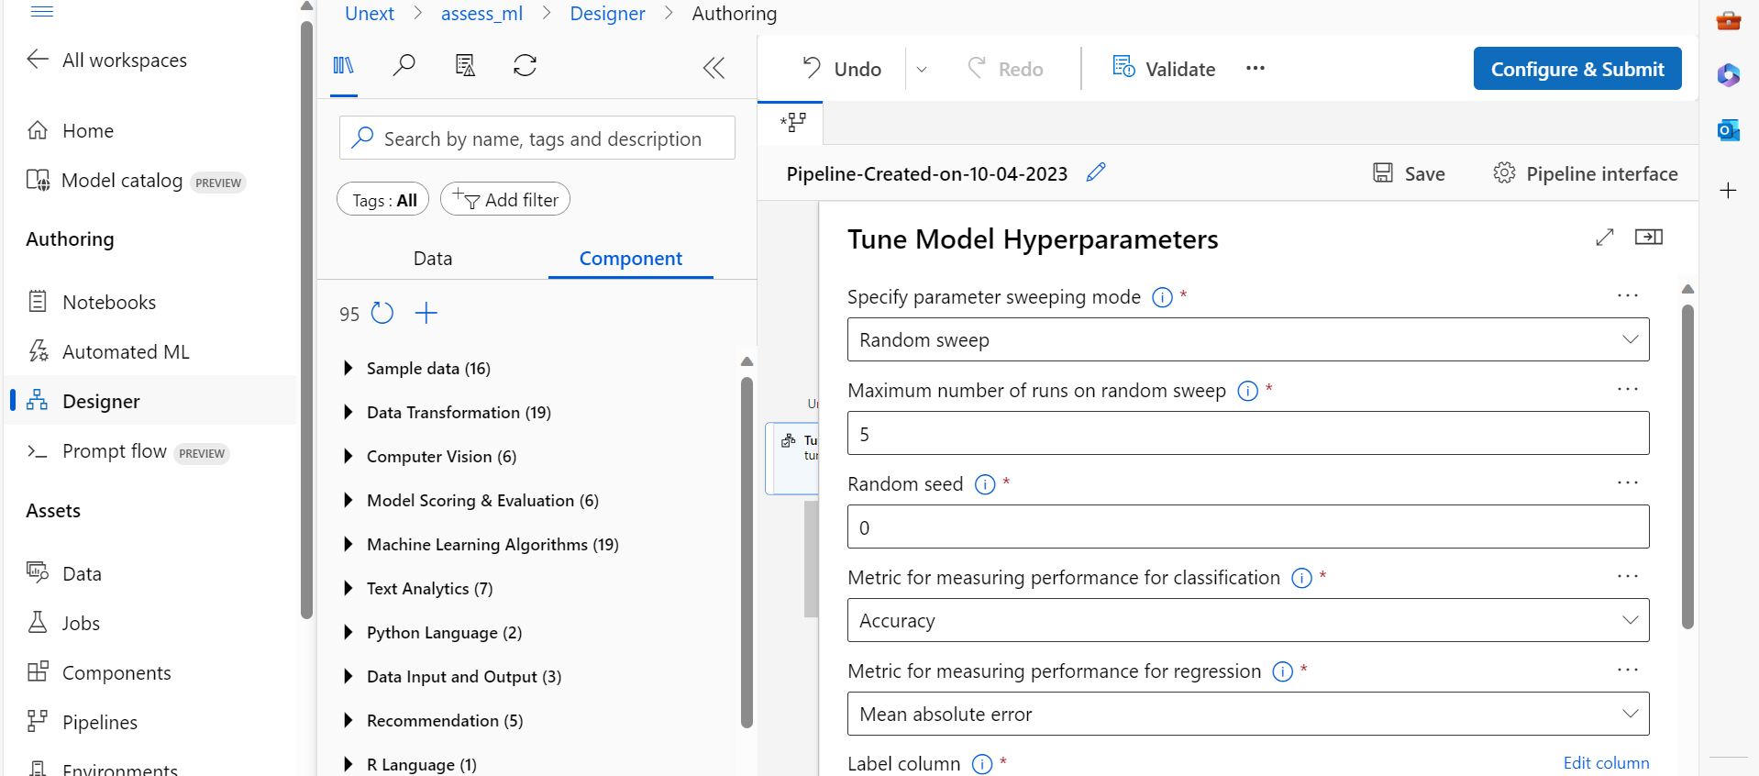

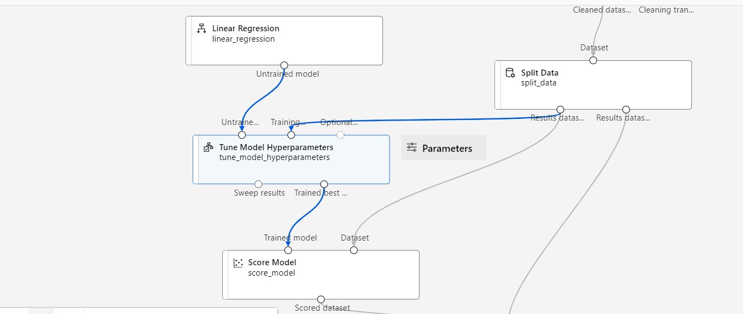

Questions:

Ans 1. First we will take the dataset and then clean it and then split the dataset into train and test the n we will apply the training dataset on training of the model. Then by using the testing data will put it to use the score model and evaluation model.After hyperparameter tuning is done evaluation is completed.

Ans 2: It is important to split the data into testing and training data to increase the accuracy of the model. If we don’t split the data into these two sets then the we might face the errors like nunderfitting and overfitting. So, in order to prevent these these errors the splitting of the data is done into these two sets probablt into 75:25 or 80:20 ratio.

Ans 3: The machine learning algorithm used for predicting the customer purchasing behaviour is the linear regression as it will consider previous purchases made by the customers means the independent variable and then predicting the whether the customer would buy it ot not being the dependent variable.

Ans 4. Hyperparameer tuning is mainly using the best parameters suitable fot the model for increasing the accuracy of the model. These are mainly picked by the programmer. bEgs of the hyperparametr tuning are learning rate , epochs , batch size and test-train ratio etc.